TITLE OF PAPER: Fewer than 15 words [Style: PMENA-Title]
Optional: Title Of Paper In Spanish or French: Fewer Than 15 Words
[Style: Pmena-Title2] - Font Small Caps
Please ensure your proposal is anonymous for review, while leaving appropriate space for author names in the final paper.

For single author: Author [Style: PMENA-Author]
Affiliation [Style: PMENA-Author]
Email address [Style: PMENA-Author]
For 2 or 4 Authors (use style below & delete this heading);
underline the presenting author(s).
Author1 [Style: PMENA-Author]  Affiliation 1  Email1 | Author2 [Style: PMENA-Author]  Affiliation 2  Email2
Author3 [Style: PMENA-Author]  Affiliation 3  Email3 | Author4 [Style: PMENA-Author]  Affiliation 4  Email4
For 3 or 6 Authors (use style below & delete this heading);
underline the presenting author(s).
Author1 [Style: PMENA-Author]  Affiliation 1  Email1 | Author2 [Style: PMENA-Author]  Affiliation 2  Email2 | Author3 [Style: PMENA-Author]  Affiliation 3  Email3
Author4 [Style: PMENA-Author]  Affiliation 4  Email4 | Author5 [Style: PMENA-Author]  Affiliation 5  Email5 | Author6 [Style: PMENA-Author]  Affiliation 6  Email6
Abstract begins here (no heading or label) [Style: PMENA-Abstract]. Should fit in 10 lines or fewer. Poster proposals should not have an abstract.
Keywords: List 1-4 keywords here [Style: PMENA-Keywords]. Keyword options are listed at 2021.pmena.org.
Text of body begins here. [Style: Normal PMENA]. Make sure you are using the Styles as suggested. This is very important to ease the compilation of the full proceedings. You should use the appropriate styles from the Styles menu in the “Home” tab of Microsoft Word and once you use the correct style, the text should appear with the correct formatting.
There should be no blank lines between regular paragraphs. The only blank lines will be above Heading 1 text and around tables or figures. Do not use any headers, footers, or page numbers.
First Level Heading [Style: PMENA-Heading 1]
Text begins here. [Style: Normal PMENA]. We repeat that the Styles are very important. Do not manually center and bold the text for your level-one headings. Please use the PMENA-Heading 1 style from the Style menu in Microsoft Word. If you do not see it, use the “More” drop-down button in the Styles menu and find it or type it in. If you do the ugly thing and manually format the heading (i.e., by manually centering the heading and manually making it bold), then Microsoft Word does not actually know that it is a heading, so it will be a real headache for the proceedings editors when they compile 1000+ pages of research reports.
Please limit your paper to no more than three levels of heading. If you are using the correct Styles in this template, then you will automatically have a blank line above the level-one headings and no blank lines around the second- and third- level headings. Again, do not manually Tab nor manually set the indentation. Use the “Normal PMENA” style for the main body text and the proper indentation will be built in.
Second Level Heading [Style: PMENA-Heading 2; first letters capitalized like Title Caps]
Text begins here [back to Style: Normal PMENA]. An additional benefit of using the Style headings is that you can easily see an outline and navigate directly to certain sections in your paper by using the View > Navigation Pane tool. You can see that the second-level headings, when you use the correct Style, appear nested underneath the first-level headings.
Third-level heading. Okay, this is one opportunity you have to do manual formatting. Please manually put the third-level heading text and period in bold-faced font. Then the text can continue in Normal PMENA Style.
Here is a second paragraph of Normal PMENA text to set up a block quote. The block quote will be formatted with a new built-in style.
Block quote sample. A quote longer than 40 words should be formatted as a “block quote”—as this paragraph is formatted [use PMENA-Block Quote style]. No quotation marks are used, the period goes at the end of the quote, and the reference goes at the end of the quote with no period after it. (Sample, 2019, p. 52)
Resume text after quote here (Indent only if new paragraph) [Style: Normal PMENA]
Transcripts: as needed here. [Style:PMENA-Transcript]
Transcript: transcript continues
Resume text after transcript here (Indent only if new paragraph) [Style: Normal PMENA]
- Bullet list item 1 [Style: PMENA-Bullet List]
- Bullet list item 2 [Style: PMENA-Bullet List]
- Bullet list item 3 [Style: PMENA-Bullet List]
Resume text after bulleted list here (Indent only if new paragraph) [Style: Normal PMENA]
- Numbered list item 1 [Style: PMENA-Bullet List]
- Numbered list item 2 [Style: PMENA-Bullet List]
- Numbered list item 3 [Style: PMENA-Bullet List]
Resume text after numbered list here (Indent only if new paragraph) [Style: Normal PMENA]
Tables and Figures
All tables and figures should be placed in the document as appropriate, with a blank line both preceding and following the table or figure. They should fit within the 1-inch margins and the full body of the document must still adhere to the number of pages allowed. Create tables using the Table feature of Microsoft Word. (Tables are those graphics consisting of rows and columns with normal alphanumeric characters in the cells; all other graphics should be designated as Figures). Use the Table and Figure Title PMENA Style for both table and figure titles, placing the table title above the table, and the figure title below the figure or graphic. Examples follow.

Table 1: Conference Deadlines [Style: Table and Figure Title PMENA]
 | Proposals Due | Final Papers Due
Research & Brief Research Reports | February 15, 2022 | May 31, 2022
Posters & Working Groups | February 15, 2022 | May 31, 2022

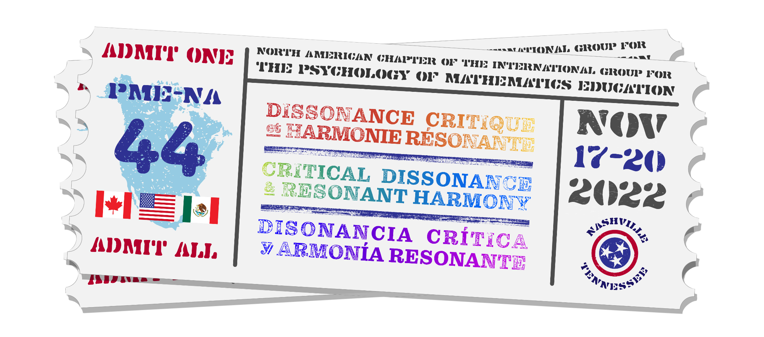
Figure 1: PME-NA 2021 Logo [Style: Table and Figure Title PMENA]

Recall that Research Reports should be no longer than 8 pages, although references are allowed to extend beyond the eighth page. Brief Research Reports should be no longer than 4 pages, although references are allowed to extend beyond the fourth page. Poster proposals should be no more than 1 page, although references are allowed to extend beyond that page. Working Group and Research Symposia proposals should be no more than 2 pages, although references are allowed to extend beyond the second page.
Footnotes
Footnotes should be used only in extreme cases. Please use Style: PMENA-FootnoteText: Font size 10 pts, No Indent .
Acknowledgments [Style: PMENA-Heading 1]
Any necessary acknowledgments should immediately precede the References. Do not put blank lines between multiple acknowledgments. Acknowledgments must fit within the page limits of your proposal (so they must fit on the 8th page or earlier for Research Reports, on the 4th page or earlier for Brief Research Reports, on the 1st page for Poster Proposals, and on the 10th page or earlier for Working Group Proposals). Only the References are allowed to extend beyond the page limit. Please make sure your paper is appropriately anonymized (“blinded”) for review, including in your Acknowledgements.
References [Style: PMENA-Heading 1]
References [PMENA-References Style]. There is no limit to the number of references cited. There should be no blank lines between references. All references should follow APA format; a variety of sample references are illustrated below. Note that titles of books are journals should be italicized, not underlined. There should be no underlined text in the manuscript.
Aguirre, J. M., Mayfield-Ingram, K., & Martin, D. B. (2013). The Impact of Identity in K-8 Mathematics: Rethinking Equity-based Practices. Reston, VA: National Council of Teachers of Mathematics.
Baker, B., Cooley, L., & Trigueros, M. (2000). A calculus graphing schema. Journal for Research in Mathematics Education, 557–578.
Bos, B. (2011). Professional development for elementary teachers using TPACK. Contemporary Issues in Technology and Teacher Education, 11(2). Retrieved from http://www.citejournal.org/vol11/iss2/mathematics/article1.cfm
Crespo, S. (2003). Learning to pose mathematical problems: Exploring changes in preservice teachers' practices. Educational Studies in Mathematics, 52(3), 243–270.
Herbst, P., & Chazan, D. (2006). Producing a viable story of geometry instruction: What kind of representation calls forth teachers’ practical rationality? In S. Alatorre, J. L. Cortina, M. Sáiz, & A. Méndez. (Eds.), Proceedings of the 28th North American Group for the Psychology of Mathematics Education Conference (Vol. 2, pp. 213–220). Mérida, México: UPN.
National Council of Teachers of Mathematics. (2000). Principles and standards for school mathematics. Reston, VA: Author.
Rasmussen, C., & Ellis, J. (2015). Calculus coordination at PhD-granting universities: More than just using the same syllabus, textbook, and final exam. In D. Bressoud, V. Mesa, & C. Rasmussen (Eds.). Making the connection: Research and teaching in undergraduate mathematics education (pp. 107–115). Washington, DC: The Mathematical Association of America.

Footnote: Avoid using, but if needed use this style. [Style: PMENA-FootnoteText]

